TARANA SINGHAL - HANDS ON FOR WEBSITE LAB

1]Creating the bucket with ucket name taranawebsite

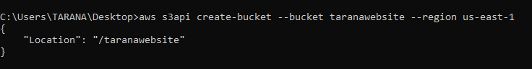

2] Putting our website as object inside bucket

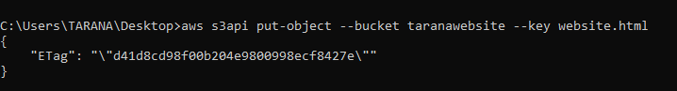

3] List the object that is inside our bucket to confirm placement



4] Uploading code to blank website.html file with copy command



5] Set S3 bucket as website



6] Presign URL of S3 object for temporary access



7] Open website in chrome through link

